Github like:
https://github.com/Ricardo-Alvear/COMP3104

GitHub commits
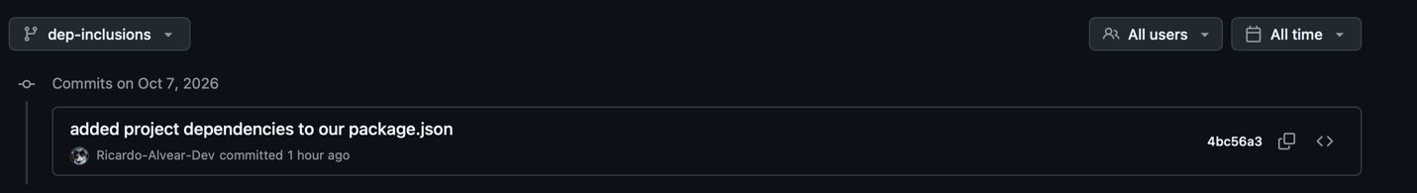

SPA Page
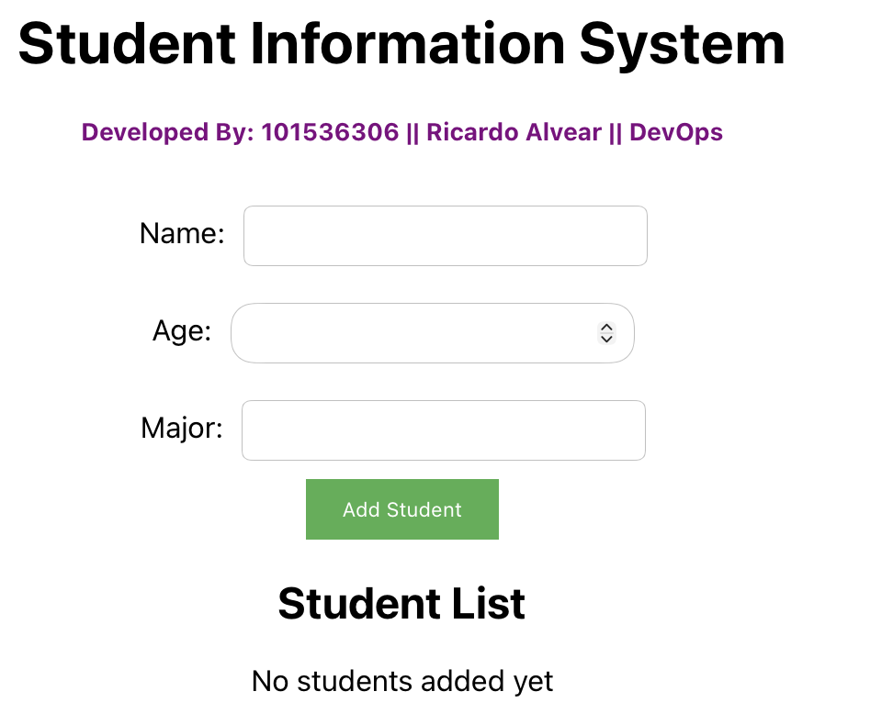

Git commands
